Assignment 2

Dinesh Kumar Paladhi

I wrote all the programs in python 2.7.2

1. Optimization of a function with real parameters.

Task 1: (Hill Climbing Search)

1. Save the hillackley.py in any folder and in putty or secure shell navigate to that folder and type “python hillackley.py”.
2. You will be given 100 outputs of the ackley’s function and all these outputs would be written to file named output.txt.
3. Using this file, I have made a plot and it is shown here.

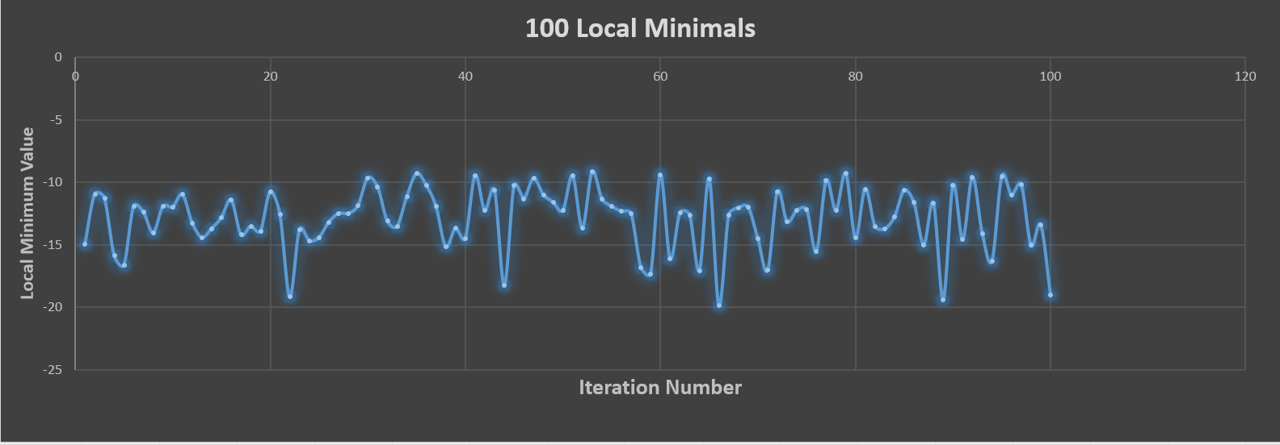

1. So out of 100 runs the minimum I got is approximately at -20 and the global minimum is approximately at -22.
2. Sample Output

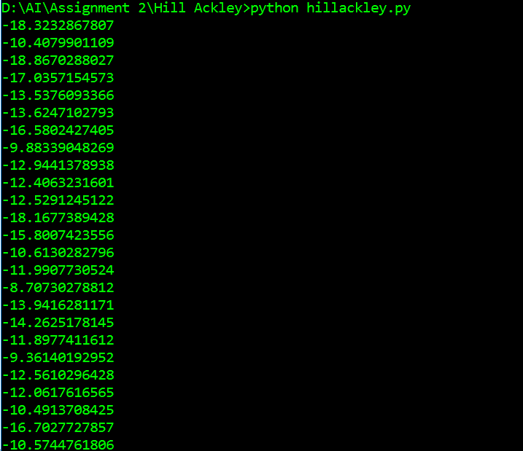

Task 2: (Differential Evolution)

1. Save the diffackley.py in any folder and in putty or secure shell navigate to that folder and type “python diffackley.py”.
2. You will be given 100 outputs of the ackley’s function and all these outputs would be written to file named outputdiff.txt.
3. Using this file, I have made a plot and it is shown here.
4. So out of 100 runs the minimum I got is approximately at -22.713 and the global minimum is approximately at -22.781.
5. Sample Output

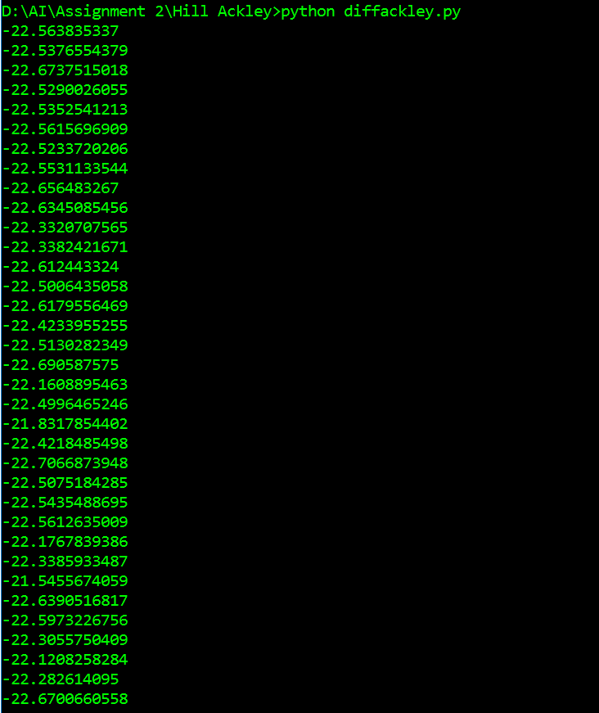

Task 3. (Analysis)

1. Hill Climbing Search program is made to run for 100 times and gave us a minimum of -20.
2. Whereas Differential Evolutions when made to run for 100 times, gave us a minimum of -22.713 which is more close to the global minimum.
3. So I fill Differential Evolution algorithm is more powerful in getting us closer to the global minimum when compared to the hill climbing search.

2. N-queens Problem

Task 1. (Hill Climbing Search)

1. Save the queenhill.py in any folder and in putty or secure shell navigate to that folder and type “python queenhill.py”.
2. Sample output for 8 Queens.

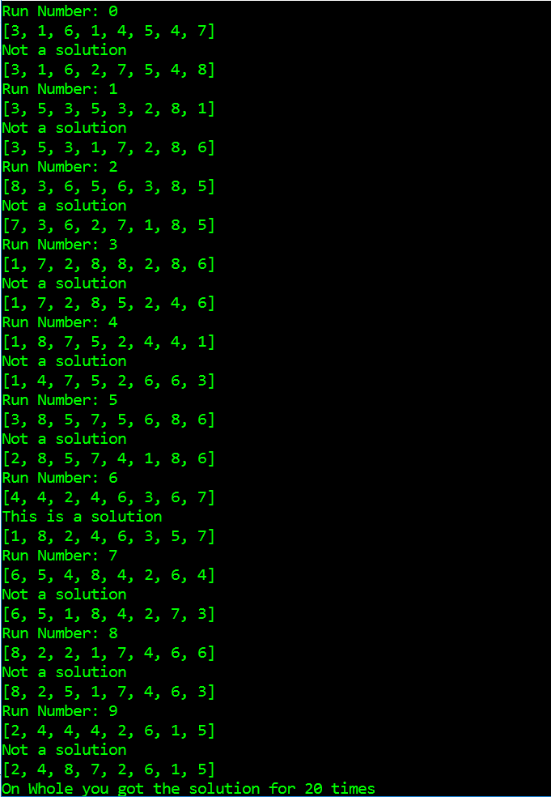

1. Sample output for 8 Queens.

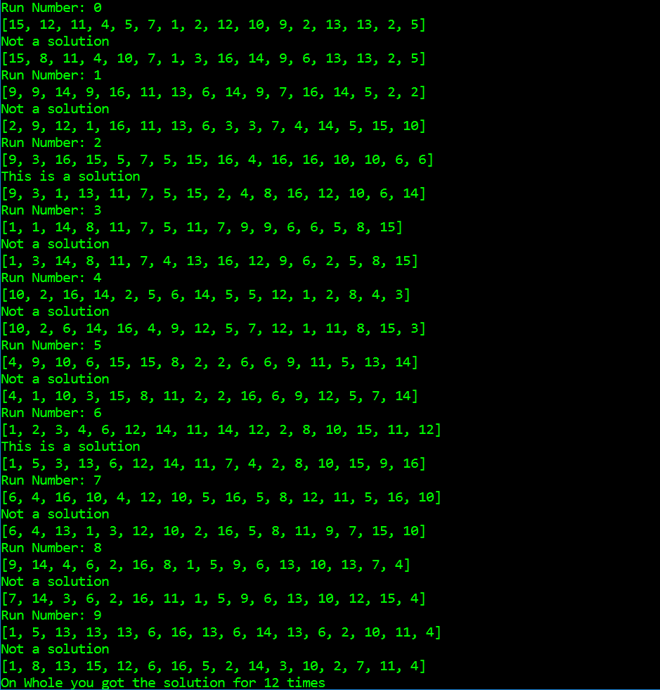

Task 2. (Genetic Algorithm)

1. Save the geneticnqueens.py in any folder and in putty or secure shell navigate to that folder and type “python geneticnqueens.py”.
2. Sample output for 8 queens

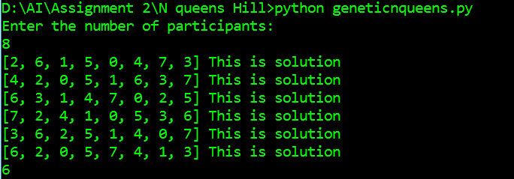

1. Sample output for 16 queens

